Network technologies in the home

LAN wireless Frequencies

**The wireless technologies most frequently used in home networks in the unlicensed 2.4GHz and 5GHz frequency range**

**Bluetooth** is a technology that makes use of the **2.4GHz band**

It is limited to low-speed, short-range communication but has advantage of communicating with many devices at the same time

**Other technologies that use 2.4GHz and 5GHz bands are the modern wireless LAN technologies** that conform to the various IEEE 802.11 standards

**They transmit at a much higher power level giving them a great range and improved throughput**

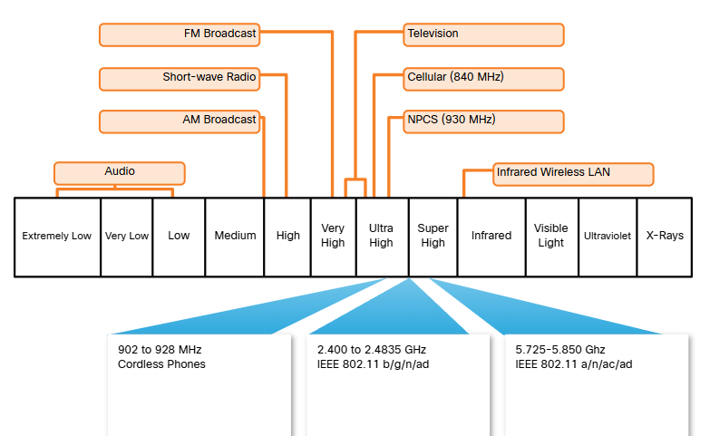

Wired network technologies

**Most commonly implemented wired protocol is the ethernet protocol**

It uses a suite of protocols that allow network devices to communicate over a wired LAN connection

An ethernet LAN con connect devices using many types of wiring media

Directly connected devices use ethernet patch cable, usually unshielded twisted pair

*More technologies*:

Category 5e cable

It’s the **most common** wiring used in a LAN

**Made of 4 pairs of wires that are twisted to reduce electrical interferance**

Coaxial cable

Has an **inner wire surrounded by a tubular insulating layer, that is then surrounded by a tubular conducting shield**

Most also have an external insulating sheath or jacket

Fiber-optic cable

Can be either **glass or plastic with a diameter about the same as a human hair** and it can carry digital info at **very high speeds over long distances**

They have a very **high bandwidth**, which enables them to carry very large amounts of data